# Adaptive Management Planning 101 Workshop: Adaptive Management Plan Development Worksheet

*Adaptive Management Forum, February 3rd, 2021*

**Instructions:**

1. Introductions (name, affiliation, why you chose this session)
2. Select a Scribe (take notes on AM Table, share screen)
3. Review and select one project from example Problem Statements
4. Complete AMP table based on the Problem Statement paragraph
   1. Start with one Goal
   2. Identify and list at least one relevant conceptual model, monitoring resource, and environmental data resource using the [IAMIT Website](https://deltacouncil.ca.gov/delta-science-program/interagency-adaptive-management-coordination)
   3. Discuss and fill out all columns in the table
   4. If you have more time, tackle a second Goal
5. Consider the following questions:
   1. What were the challenges with translating the Problem Statement to the Adaptive Management Table?
   2. What other resources could be added to the webpage?
   3. What are potential issues with developing trigger levels and potential management responses?
   4. Other, thoughts, reflections or questions?
6. If you have technical issues, please return to the main room or email [engage@deltacouncil.ca.gov](mailto:engage@deltacouncil.ca.gov)

**Example Problem Statements**

*Review and choose one as a group*

1. **Seasonal Floodplain**: This project aims to restore aquatic species habitat by reconnecting upland stream to seasonal floodplain. The project will intentionally degrade 500 meters of an earthen berm to allow for seasonal inundation of a former floodplain area during storm events. This project will produce aquatic food web resources, create seasonal habitat for avian species, restore native plants through planting and reduce high flows downstream from the created floodplain, reducing the risk of urban flooding.
2. **Subsidence Reversal**: This project will create managed freshwater wetlands to increase surface elevations on a subsided area and provide seasonal habitat for migratory bird species. The project will construct an interior levee on a former corn field, engineer the surface elevations to support target wetland plant species and flood with water year-round. The project will include multiple elevations (shallow water wading habitat, meso-water freshwater marsh, and deep open water) to target multiple species of birds. The project will also reverse subsidence through the accumulation of wetland peat soil.

# Setback Levee: This project will create off-channel habitats for fish species off the main stem of a river. The project will construct 200m of setback levee to address structural issues, leave remnant levee with connections open on both sides to create off channel habitat, and plant native riparian species to provide cover. The project will slow water speeds, allow for the accumulation of detritus, shade water to reduce temperatures, and increase food resources for native fish species.

**Table 1:** Blank adaptive management table (to be completed by group)

|  |  |  |  |  |  |  |
| --- | --- | --- | --- | --- | --- | --- |
| **Goals** | **Objectives** | **Expected Outputs and Outcomes** | **Monitoring Category** | **Monitoring**  **Metrics** | **Trigger level (related to metrics)** | **Potential Management Response** |
|  |  |  |  |  |  |  |

**Table 1:** Blank adaptive management table (continued)

|  |  |  |  |  |  |  |
| --- | --- | --- | --- | --- | --- | --- |
| **Goals** | **Objectives** | **Expected Outputs and Outcomes** | **Monitoring Category** | **Monitoring**  **Metrics** | **Trigger level (related to metrics)** | **Potential Management Response** |
|  |  |  |  |  |  |  |

**Table 2:** Example Adaptive Management Table. Example parameters are included in bold.

|  |  |  |  |  |  |  |  |
| --- | --- | --- | --- | --- | --- | --- | --- |
| **Goals** | **Objectives** | **Expected Outputs and Outcomes** | **Monitoring Category** | **Monitoring**  **Metrics** | | **Trigger level (related to metrics)** | **Potential Management Response** |
| Broad statements that propose general solutions  **Increase habitat for juvenile fish** | Quantitative, specific narrative statements of desired outcomes that allow for evaluation  **Create shaded, off channel habitat to reduce both flow velocities and water temperature** | Output: On-the-ground implementation and management actions  **Construction and connection of off-channel riparian habitat**  Outcome: Ecosystem responses to management actions  **Slower flow, lower temperature, and higher juvenile fish density compared to main channel** | Physical  **Channel morphology**  Biotic  **Juvenile fish**  Hydrologic  **Water temperature**  **Flow**  Other? | **Channel width**    **Fish abundance**  **(compared to channel)**  **Water temp**  **Flow**  **(compared to channel)** | **Channel width narrows to 10ft**  **Fish abundance**  **decreases >10% from baseline**    **Water temperature within 1.5 °C of channel**  **Flow rate >80% of channel flow** | | **Widen channel to 20ft or more and monitor**  **Consult with advisory team, analyze data to refine conceptual model and act accordingly**  **Increase shading by planting native riparian species**  **Install large woody debris** |

**Table 3**. **Example of an Adaptive Management Table** (modified after Table 5 in [Adaptive Management and Monitoring Plan, Yolo Flyway Farms Restoration Project](https://coveredactions.deltacouncil.ca.gov/services/download.ashx?u=9c5baa30-72b3-4d4a-ad1f-7b9642142bed), ICF 2017)

|  |  |  |  |  |  |  |
| --- | --- | --- | --- | --- | --- | --- |
| **Goals** | **Objectives** | **Expected Outputs and Outcomes** | **Monitoring Category** | **Metrics** | **Trigger level** | **Potential Management Response** |
| 1. Enhance regional food web productivity and export to Delta in support of delta smelt and longfin smelt recovery. | No tidal muting occurs within the site. | Output: Construction of breaches and new channels.  Outcome: Increased tidal exchange and excursion, leading to increased export of primary and secondary productivity from the site | Physical and Hydrology | * Elevation and topography including channel morphology and pond depths * Changes in tidal regime * Residence time in ponds and other habitats | Channel cross-section declines in area for 2 or more years in a row resulting in tidal muting within the site. An obstruction (tree, derelict vessel) lodged in the breach, resulting in tidal muting within the site. | The Land Owner will coordinate with the FAST on appropriate action(s) to take including, but not limited to, dredging to appropriate dimensions to maintain tidal exchange. Remove obstruction from channel. |
|  | Food web contributions from the Project site are higher than from boundary conditions (Toe Drain). Food web contributions from the various habitat components within the site are maximized to the extent possible |  | Food Web | * Chlorophyll a concentration * Phytoplankton abundance and community composition * Zooplankton abundance and community composition | Food web exports are lower in concentration than those found in the Toe Drain channel. | Modify elevations within the site to adjust residence time. |

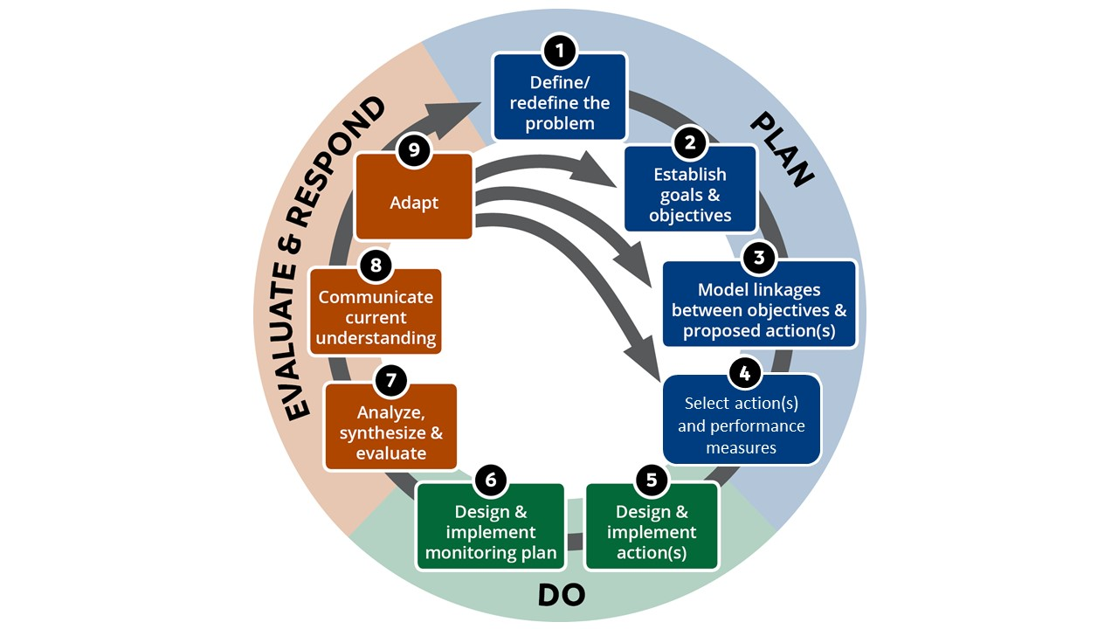

**Figure 1**. The adaptive management cycle as described in the Delta Stewardship Council’s Delta Plan.[1] The shading represents the three broad phases of adaptive management (Plan, Do, and Evaluate and Respond), and the boxes represent the nine steps within the adaptive management framework. The circular arrow represents the general sequence of steps. The additional arrows indicate possible next steps for adaptation (e.g., revising the selected action based on what has been learned). These steps are explained in detail in Delta Plan Appendix C1.

# Adaptive Management Process

Step 1: Define the problem. Adaptive management depends on a clear understanding of the problem to be addressed through some combination of science, management, and policy.

Step 2: Establish goals, objectives, and performance measures. Goals and objectives provide specific guides or targets for adaptive management, and performance measures indicate whether actions are working well. How are performance measures identified and employed? What are some common performance measures for your projects?

Step 3: Model linkages between objectives and proposed action(s). Developing models helps define the structure and relationships of the system being managed. Models may be conceptual, analytical, simulation (of varying complexities), and involve probabilistic risks or scenarios. How are you using models, of which type(s)? How do you decide what kind of modeling is needed or justified, or how detailed it should be?

Step 4: Select actions: Research, pilot, or full-scalE. Depending on the situation, the state of existing knowledge of the system, the uncertainties and risks of undertaking a planned action, its costs, and other factors, additional research (literature, modeling, field observations or experiments) may be needed before implementation, or it may be useful to conduct a pilot study. What is done in your program, and how are decisions made about what to do? What steps are taken to assemble and make accessible a knowledge base for the project or problem? How is targeted research incorporated into adaptive management?

Step 5: Design implementation action(s) with monitoring. Are details of adaptive management and monitoring in place before a project is started.

Step 6: Implement action(s) and monitoring. Monitoring generates lots of data. How are data managed? Are data bases linked with other data bases outside the project?

Step 7: Analyze, synthesize, and evaluate. When is analysis done after or during implementation? What kinds of project evaluation are common?

Step 8: Communicate current understanding. Communication of analysis results and synthesis of scientific data usually requires translation into readily understandable messages for managers and decision-makers. When is this done, how, and by whom?

Step 9: Adapt/respond. How are decisions made about whether to change goals and objectives, revise or conduct more modeling, or conduct additional research or take different actions to achieve the objectives?

1. Delta Stewardship Council. “[The Delta Plan; Appendix C](https://www.deltacouncil.ca.gov/pdf/delta-plan/2013-appendix-c-adaptive-management.pdf).” Sacramento, CA, 2013.